EXPERIMENT 29
ITA0305-Mobile Computing For App Development

29.Create wireframes for a collaborative mobile app using Figma, showcasing the peerto-peer interactions in real-time.
Aim: Wireframes for a collaborative mobile app,showcasing the peer-to-peer interactions in real-time using figma

Procedure:
- Open Figma
- Create a new file
- Select the Frames
- Design Visual Elements 5. Make it Interactive
- Add icons on the Frame
- Incorporate Multimedia
- Storyboard Animation
- Review and edit the Prototype
- Save and Share
Design:

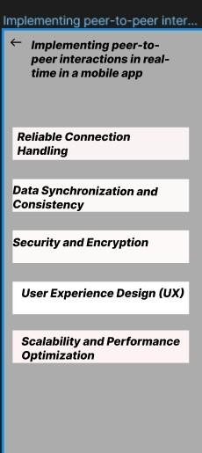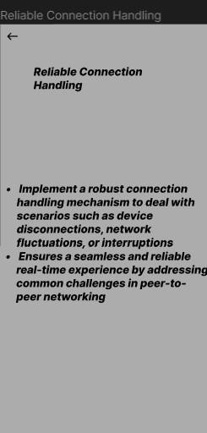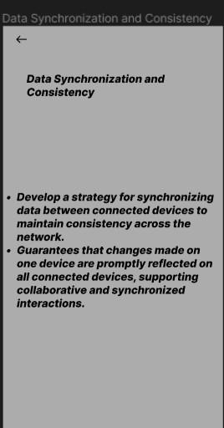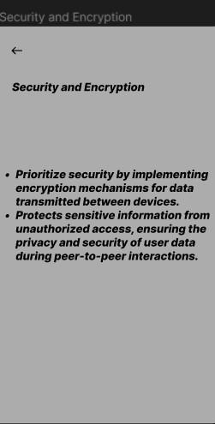
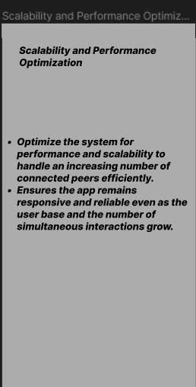

Prototype:
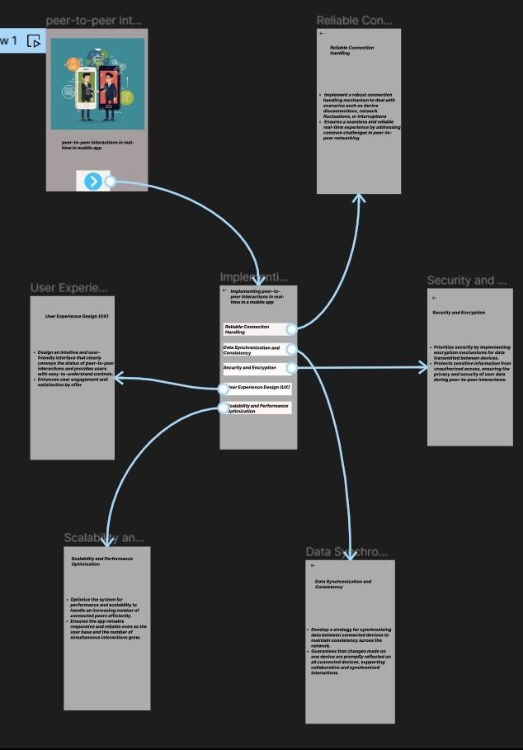
Result:
HenceWireframes for a collaborative mobile app,showcasing the peer-to-peer interactions in real-time using figma have been created successfully

